**PROGRAM#1**

**Aim:** Write a program to search an element from a given list using **Linear Search** method.

**Code:**

#include<stdio.h>

#include<conio.h>

#define size 20

int main()

{ int arr[size],no,i,srch;

clrscr();

printf("Enter total number of elements you want to enter in the array: ");

scanf("%d",&no);

printf("Enter elements of the array.\n");

for(i=0;i<no;i++)

{ scanf("%d",&arr[i]);

}

printf("Enter no to be searched\n");

scanf("%d",&srch);

for(i=0;i<no;i++)

{ if(arr[i]==srch)

break;

}

if(i==no)

printf("Search Unsuccessful\n");

else

printf("Position of the element to be searched is: %d", i+1);

getch();

return 0;

}

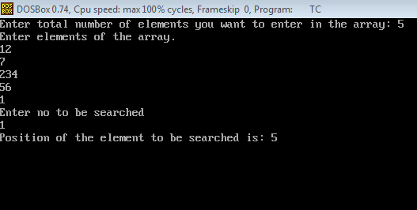

**PROGRAM#2**

**Aim:** Write a program to search an element from a given list using **Binary Search** method.

**Code:**

#include<stdio.h>

#include<conio.h>

#define size 20

int main()

{ int first=0,last,mid,arr[size],no,i,srch;

clrscr();

printf("Enter no of elements: ");

scanf("%d",&no);

printf("Enter elements in sorted order.\n");

for(i=0;i<no;i++)

{ scanf("%d",&arr[i]);

}

printf("Enter no to be searched\n");

scanf("%d",&srch);

last=no;

mid=(first+last)/2;

while(arr[mid]!=srch && first<=last)

{

if (arr[mid]<srch)

first=mid+1;

else

last=mid-1;

mid=(first+last)/2;

}

if(first>last)

{

printf(“Search Unsuccessful\n”);

}

else

printf("Position of the element to be searched is: %d", mid+1);

getch();

return 0;

}

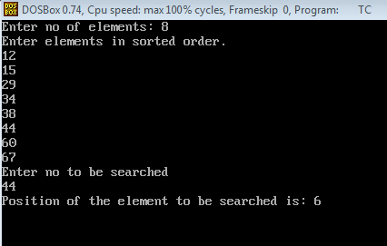

**PROGRAM#3**

**Aim:** Write a program to sort the elements of a given list using **Bubble Sort** method.

**Code:**

#include<stdio.h>

#include<conio.h>

#define size 5

int main()

{ int arr[size],temp,i,j;

clrscr();

printf("Enter %d elements\n",size);

for (i=0;i<size;i++)

{ scanf("%d",&arr[i]);

}

for(i=0;i<size;i++)

{ for (j=0;j<size-i-1;j++)

{ if (arr[j]>arr[j+1])

{ temp=arr[j];

arr[j]=arr[j+1];

arr[j+1]=temp;

}

}

}

printf("Sorted elements are\n");

for (i=0;i<size;i++)

{ printf("%d ",arr[i]);

}

getch();

return 0;

}

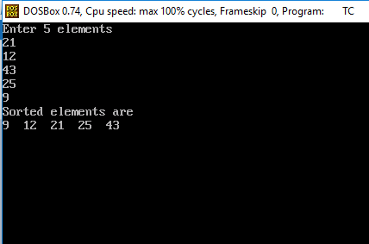

**PROGRAM#4**

**Aim:** Write a program to sort the elements of a given list using **Selection Sort** method.

**Code:**

#include<stdio.h>

#include<conio.h>

#define size 20

int min(int ,int ,int *);

int main()

{ int arr[size],temp,loc,i,num;

clrscr();

printf("Enter number of elements you want to sort.\n");

scanf("%d",&num);

printf("Enter %d elements\n",num);

for (i=0;i<num;i++)

{ scanf("%d",&arr[i]);

}

for(i=0;i<num;i++)

{ loc=min(i,num,arr);

temp=arr[loc];

arr[loc]=arr[i];

arr[i]=temp;

}

printf("Sorted array is: \n");

for (i=0;i<num;i++)

{ printf("%d ",arr[i]);

}

getch();

return 0;

}

int min(int k,int num, int *arr)

{ int min=arr[k],loc=k,i;

for(i=k;i<num;i++)

{ if (arr[i]<min)

{ min=arr[i];

loc=i;

}

}

return loc;

}

